**Intelligent Tour Guide**

**Project Proposal**



**Session 2021-2025**

**Submitted By:**

**Ateeq Aslam 2021-CS-638**

**Jamal Mustafa 2021-CS-631**

**Javeria Ijaz 2021-CS-604**

**Supervised by:**

**Sir Usman Ghani**

**Co-Supervised by:**

**Dr. Irfan Yousaf**

**Department of Computer Science, New Campus**

Contents

Proposal Synopsis 5

1.1 Abstract: 5

1.2 Introduction 5

1.3 Problem Statement 6

1.4 Objectives 7

1.5 Scope/Features 8

1.6 Related Work 9

1.7 Proposed Methodology/System 13

1.8 Tools and Technologies 16

1.9 Team Members Individual Tasks/Work Division 17

1.10 Data Gathering Approach 17

1.11 Timeline/Gantt chart 18

1.12 References 19

**List of figures:**

Figure 1 14

Figure 2 15

Figure 3 18

**List of Tables**

Table 1(team members individual task /work division) 17

**Chapter 1**

# Proposal Synopsis

# Abstract:

"Travel opens your mind, but real exploration touches your soul." This idea captures the essence of tourism, where every place brings its own adventure. Pakistan, with its rich history, culture, and stunning landscapes, offers an experience like no other. Unfortunately, most tourism apps fall short, leaving travelers with unreliable information and poor guidance To address these challenges, we introduce a state-of-the-art application designed to be a comprehensive tour guide for Pakistan. Our app will ensure that every traveler can uncover both renowned landmarks and hidden gems, by facilitating direct connections with locals enriches the travel experience, allowing users to engage deeply with Pakistan’s vibrant traditions. Through its intuitive interface and interactive Chabot, the app also provides instant assistance and addresses common travel issues. With our proposed solution, we aim to make each journey through Pakistan not only memorable but truly transformative.

# 1.2 Introduction

Tourism [1] is about more than just visiting new places; it's a chance to explore different cultures, meet new people, and experience life in exciting ways. It helps us grow by opening our minds to new ideas and perspectives. Through tourism, we can connect with the world, create lasting memories, and discover things that inspire us. Every trip offers a new adventure, making life richer and more meaningful. Pakistan is a country with beautiful landscapes and a rich cultural history. Exploring it can offer unique experiences, but there are challenges that often stop travelers from fully enjoying their trip. (tourism, 2023)

**Complex travel plan:** Creating a detailed travel plan that captures the best of Pakistan can be quite challenging. Deciding which landmark to visit, managing expenses can overwhelm even experienced travelers.

**Discovering Hidden Gems:** Pakistan’s appeal extends beyond famous landmarks to hidden treasures hidden away off the beaten path. However, the lack of accessible information and fragmented recommendations makes finding these gems a challenging task.

**Fragmented Information Sources:** Too much information scattered across forums often leads to confusion and uncertainty. Find accommodation, attractions, and activity recommendations in various destinations for an easy travel experience.

**Language Barriers:** Effective communication is critical to meaningful travel experiences, but language differences present a significant barrier. The inability to understand local customs and traditions reduces the possibility of genuine cultural exchange.

In response to these challenges, we launched our intelligent travel guide app. Designed as a travel companion, our app uses the latest technology to provide personalized, helpful guides that connect easily with local experts in personalized programs, discover hidden gems, synthesis and language translation services. With our app in hand, travelers can discover Pakistan's true highlights, and make unforgettable memories that will last longer than the trip. Due to the lack of a single platform for tour information about Pakistan, tourists face difficulties in discovering the country, which can sometimes impact their decision to visit

.

# 1.3 Problem Statement

Many challenges are encountered when arranging a tour to Pakistan for the first time. Significant barriers include creating personalized itineraries and discovering hidden cultural gems. Additionally, they face challenges with language barriers and lack real-time support. This absence of an intelligent, user-friendly platform limits their ability to fully explore the country and hampers their travel experience. An intelligent tour guide app is needed to simplify trip planning, provide tailored recommendations, offer real-time chatbot assistance, and include language conversion to enhance the exploration of lesser-known attractions and improve overall travel experience.

# 1.4 Objectives

The project aims to revolutionize the way tourists travel in Pakistan. Its main objectives include the ability to explore independently, personalized travel plans, discovering hidden gems and ensuring communication and support easy for all tourists.

1. **Empower Independent Exploration:** The project aims to help travelers explore Pakistan with confidence, no matter their experience level. By offering detailed information and useful tools, it will empower travelers to navigate the country at their own pace and based on their interests.
2. **Personalized Travel Planning:** Instead of offering a fixed itinerary, the project allows users to design their own travel experiences based on their interests, budget, and time. This approach helps both new and seasoned travelers create personalized and memorable adventures that suit their individual preferences.

1. **Unveiling Hidden Gems:** To enhance the travel experience, the project will include the contact details of experienced locals guides that can guide the tourists to visit the real hidden gems in that place.
2. **Ensuring Seamless Communication & Support:** To provide a smooth travel experience, the project features a user-friendly chatbot that offers real-time assistance with location-specific questions and guidance. This helps travelers get the information they need to navigate Pakistan confidently and comfortably.

Through these objectives, the web application aims to transform travel in Pakistan by empowering travelers of all backgrounds to explore independently, forge meaningful connections with local culture, and create lasting memories in this incredible nation.

# 1.5 Scope/Features

# 

**Rating-Based Tour Generation**: Utilization of user-generated ratings and reviews to generate tour recommendations, helping users discover popular and highly rated destinations and experiences based on peer feedback.

**Custom Tour Generation**: User can select the places that he wants to visit to generate custom tour including only those places. This will provide flexibility and personalization to our application.

**User Accounts and Personalization:** The option for users to create accounts, allowing for personalized experiences such as saving preferences, viewing past activity, and receiving tailored recommendations.

**Local Guide Profile**: A dedicated profile section for local guides, where they can showcase their expertise, experiences, and availability for guiding tours.

**Local Guide Profile Personalization**: Customization options for local guides to personalize their profiles, including adding photos, descriptions, and specifying areas of expertise or interest.

**Responsive Design**: Ensuring that the app is optimized for various devices and screen sizes, providing a consistent and user-friendly experience across desktops, tablets, and smartphones.

**User-Friendly Interface**: An intuitive and easy-to-navigate interface designed to enhance user experience and facilitate seamless interaction with the app's functionalities.

**Chatbot:** Integration of a chatbot feature to provide real-time assistance and support to users, answering queries, offering recommendations, and addressing concerns related to travel in Pakistan.

**Language Translation:** Translating sentences of user into Urdu

(National Language of Pakistan) for communicating and interacting with natives.

**Cost Estimation:** Estimating costs of the tour including traveling and accommodation expenses.

# Related Work

Pakistan's captivating landscapes, rich cultures, and diverse experiences beckon travelers worldwide. Yet, navigating the current travel landscape in Pakistan can be frustrating for both tourists and travel agencies. Fragmented information, a lack of centralized resources, and limited online booking options hinder a seamless travel experience.

Let’s take a ride on our examination of what the current existing systems are doing and what solution for extended features of a real time problem, our project is proposing

* **Tour planner**[**[2]**](https://www.tourplanner.pk/)

Weakness: It has limited coverage of destinations and offers (a leading hotel consolidator and one stop shop for travel products. Provides hotel reservation facility in eight cities and four summer destination of Pakistan). No user specific(personalized) tours

We plan to ask personalized questions to the user and suggest places according to his mode. The places would satisfy certain criteria (we would recommend them if they achieved a certain threshold value). We don’t have restrictions of places in our system, and we also provide a chatbot to respond to user custom queries.

* **Google Map**[**[3]**](https://maps.google.com/)

Weakness:While Google Maps provides navigation, it lacks tour planning, personalized recommendations and it has no information related to hidden gems which only a local could tell curated tours.

Proposed Project Solution:

The proposed project integrates routing algorithms with cost options to optimize travel plans, offers locals as a guide to explore hidden gems and a chatbot to answer custom queries.

* **K-ptourism** [**[4]**](https://staging.kptourism.com/)

It's restricted to Government Rest Houses in Khyber Pakhtunkhwa, limiting choices for travelers. We plan to ask personalized questions to the user and suggest places according to his mode. The places would satisfy certain criteria (we would recommend them if they achieved a certain threshold value). We don’t have restrictions of places in our system, and we also provide a chatbot to respond to user custom queries.

* **TripAdvisor**[**[5]:**](https://www.tripadvisor.com/)

Although TripAdvisor offers reviews and recommendations, it doesn't route tours or real-time support through a chatbot and no way to explore hidden gems. Our project includes a user chatbot feature for Real-time support and addresses queries about locations and attractions. Additionally, it offers locals the chance to explore hidden gems.

* **Airbnb Experiences**[**[6]**](https://www.airbnb.com/)

While Airbnb Experiences offers curated local activities, it doesn't optimize travel plans or provide comprehensive city exploration features. It also has a large scope so specific places could not be visited. The proposed project not only offers curated tours and city exploration activities but also optimizes travel plans using routing algorithms with cost options, ensuring efficient navigation and enhanced exploration opportunities.

* **Trip.com**[**[7]**](https://www.googleadservices.com/pagead/aclk?sa=L&ai=DChcSEwjWrdG6pr-IAxUziWgJHaK3FIEYABAAGgJ3Zg&co=1&ase=2&gclid=EAIaIQobChMI1q3Ruqa_iAMVM4loCR2itxSBEAAYASAAEgKNvfD_BwE&ohost=www.google.com&cid=CAASJuRo3ygiQ0VHsmzzeGMDTylN18-k4qmlPx_s_XisF_2yHiUT2cJB&sig=AOD64_14R6jDEiJp3bN28MgBN0F23IzPVw&q&nis=4&adurl&ved=2ahUKEwixqsy6pr-IAxX6S_EDHUVjBzcQ0Qx6BAgIEAE)

Although Trip.com offers booking services and travel information, it lacks personalized suggestions for exploration and real-time support. The proposed project provides personalized suggestions for exploration activities, integrates a user chatbot feature for real-time support, gathers feedback, and addresses queries about locations and attractions. Additionally, it offers curated tours and optimization of travel plans using routing algorithms with cost options

.

* **Discoverpak** [**[8]:**](https://www.discoverpakistan.tv/)

It has limited coverage of destinations and offers (a leading hotel consolidator and one stop shop for travel products. No user specific(personalized) tours User can plan his own custom tour including the places he wants to visit

* **Booking.com**[**[9]**](https://www.booking.com/)

It doesn't offer specialized insights and recommendations for travelers specifically interested in Pakistan due to its larger scope. We'll focus exclusively on Pakistan's tourism landscape, providing specialized features and insights tailored to the country's unique attractions.

* **MakeMyTrip**[**[10]**](https://www.makemytrip.com/?srsltid=AfmBOoppV73ciKBO5YfP8mtPH6Lk7Ur8TsIdxKsRB1VhV-VPAJyxuvft)

It does not cover Pakistan and mainly focusses on Indian and common international places. We'll provide specialized features and insights tailored to Pakistan's tourism landscape, including curated tour packages and personalized itineraries

* **Wanderlust Pakistan** [**[11]:**](https://www.wanderlust.com.pk/)

It does not provide custom and personalized tours according to some generic questions. We would ask user some questions and suggest personalized tour to him and provide him the option to make his own tour

* **Evaluation of Intelligent Routes for Personalized Electronic Tourist Guides:**

It does provide personalized recommendations and custom tour generation buts lacks the ability to predict travel cost estimation and does not support language translation and there is no chatbot. [12] We don’t only make customized and personalized tours but also provide features like language translation, chatbot, travel cost estimation.

**Personalized tourism route recommendation based on user’s active interests:**

It only provides recommendation based on previous user history without considering the tourism cost and does not provide facilities like chatbot and predicting tour according to sentiment analysis. [13]: We predict tours keeping in mind the ratings of the places which fall in user points of interest, and we provide features like chatbot language translation

* **Personalized tourism route recommendation based on user’s active interests:**

TripBuilder, a smart system that plans customized sightseeing tours in cities. It gathers categorized Points of Interests (like landmarks, museums) from Wikipedia and geo-tagged photos from Flickr. By analyzing these photos as clues of tourists' activities, it figures out their typical routes and links them to city attractions. It does not allow custom tours and there are no extra features like chatbot and language translation and travel cost analysis. [8]

We don’t only provide personalized tours generation but also allow to make custom tours and there are not extra features like chatbot and language translation and travel cost analysis**.**

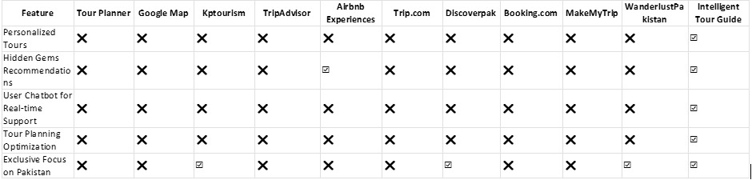

# 

# 1.7 Proposed Methodology/System

The proposed methodology mentioned in following figure for developing the application will incorporate a structured and iterative approach, focusing on efficient development and rigorous testing to ensure a high-quality product. The following steps outline the methodology:

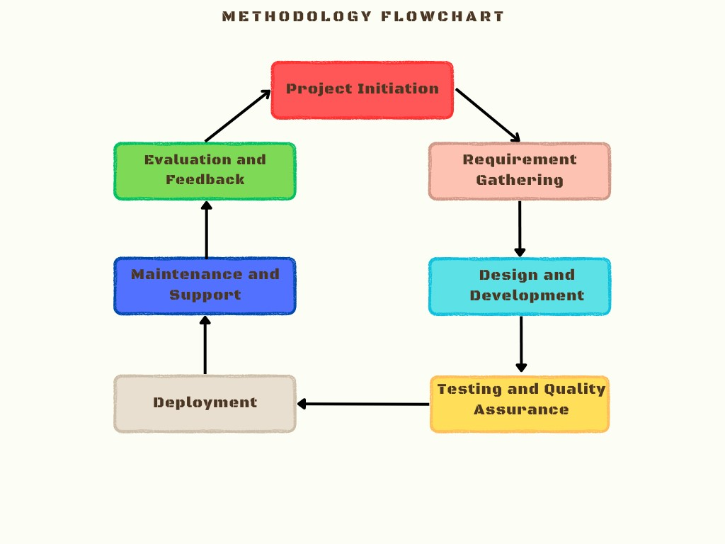

**Figure 1: Methodology Flowchart**

**Project Initiation:**

* Define clear project scope, objectives, and goals, aligning with the vision of providing a comprehensive travel platform for both travel agencies and tourists.

Conduct initial research to identify key challenges and opportunities within the travel industry, informing project direction and strategy.

**Requirement Analysis:**

* Engage stakeholders, including travel agencies and potential users, through interviews, surveys, and feedback sessions to gather comprehensive requirements.
* Prioritize requirements based on their impact on user experience, business objectives, and technical feasibility.

**Design and Development:**

* Adopt an agile development methodology shown in following figure, working in iterative sprints to incrementally build and refine the application.

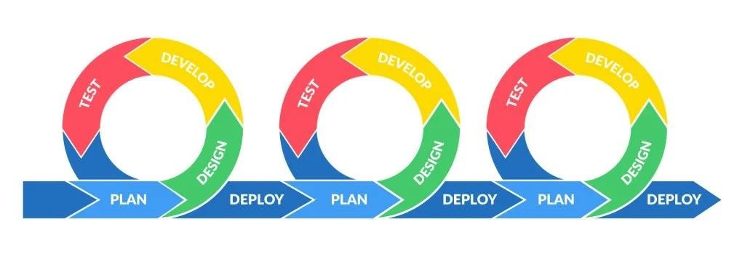

**Figure 2: Agile Cycle**

* Utilize modern front-end and back-end technologies to develop a responsive, user-friendly platform with essential features such as user authentication, search functionality, booking systems, and review mechanisms.

Ensure scalability and flexibility in the architecture to accommodate future enhancements and updates.

**Testing and Quality Assurance:**

* Conduct thorough testing throughout the development lifecycle, including unit testing, integration testing, and user acceptance testing.
* Implement continuous integration and deployment practices to identify and address issues promptly.
* Utilize automated testing tools where applicable to streamline the testing process and improve efficiency.

**Deployment and Maintenance:**

* Deploy the application to a staging environment for final validation and testing by stakeholders.
* Address any identified issues or bugs before deploying the application to production.
* Establish a robust maintenance plan to provide ongoing support, updates, and enhancements to the application post-launch.

**Evaluation and Feedback:**

* Gather feedback from users and stakeholders through usability testing, surveys, and analytics tools.
* Analyze user behavior and engagement metrics to identify areas for improvement and inform future iterations of the application.

Emphasize that user feedback and metrics are continuously gathered and analyzed.

* Explain how this feedback drives adjustments and improvements in subsequent iterations.

# 1.8 Tools and Technologies

**Documentation:**

* Microsoft Word
* Latex

1. **Wire frames/ User interface**:
   * Figma • Pencil software
2. **Web Application development**:
   * Vs Code
3. **Development**:
   * MERN & NEXTJS • APPWRITE

**5.Testing:**

* Selenium
* JEST

# 1.9 Team Members Individual Tasks/Work Division

|  |  |
| --- | --- |
| **Team members** | **Work** |
| Ateeq Aslam | Backend, front-end, documentation |
| Jamal Mustafa | Backend, front-end, documentation |
| Javeria Ijaz | Backend, front-end, documentation |

**Table 1**

# 1.10 Data Gathering Approach

**1.10.1 Interviews with potential users:** One-on-one interviews can be conducted with potential users to understand their needs, preferences, and pain points related to travelling. This can help in identifying the key features and functionalities that should be included in the system.

**1.10.2 Online surveys/questionnaires**: Online surveys/questionnaires can help in identifying the user demographics, travelling behaviors, and preferences.

**1.10.3 Market research**: Conducting market research can help in identifying the key players in the travelling websites. This can help in designing a system that can stand out from the competition.

**1.10.4 Focus groups:** Focus groups can be organized with potential users to gather feedback on the system’s user interface, functionality, and overall user experience. This can help in identifying any areas that need improvement or modification.

**1.10.5 Feedback and reviews from existing users:** Feedback and reviews from existing users of other travel systems can help in designing a system that meets the needs and expectations of potential users.

# 1.11 Timeline/Gantt chart

Based on the Work Breakdown Structure (WBS), a timeline or Gantt chart( In Figure 3 ) showing the allocation of time to the project phases or iterations should be developed. This Gantt chart would identify major milestones with their achievement criteria. It must contain duration estimation of all the necessary activities to be carried out during the project development along with the human resources responsible for the respective tasks. Activity dependencies are also required to be mentioned in it.

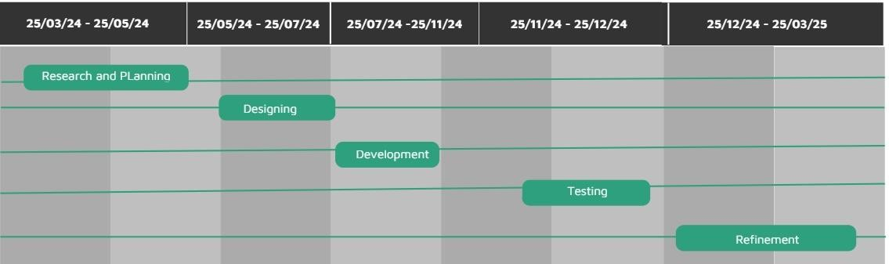

***Figure 3:*  Gantt Chart**

# 

# 1.12 References

[1] Wikiepedia

<https://www.wikipedia.org/>

[2] M. T. L. &. O. A. Ander Garcia, "Evaluation of Intelligent Routes for Personalized Electronic Tourist Guides," 2012.

<https://www.atlantis-press.com/proceedings/iceeecs-16/25865659>

[3] G. A. Barros, "A Context-Aware Mobile Personalization System," 2013.

<https://www.tandfonline.com/doi/abs/10.1080/19322909.2023.2221477>

[4] C. H. Xinling Wang, "Design and Implementation of an Intelligent Tourist Guide System," 2016.

<https://link.springer.com/chapter/10.1007/978-3-642-03964-5_5>

[5] N. N. Yrjo Lappalainen, "A Custom AI Library Chatbot Using the ChatGPT API," *Journal of Web Librarianship,* 2023.

<https://dl.acm.org/doi/abs/10.1145/1562764.1562799>

[6] C.-C. Y. &. H.-p. Chang, "Personalized Location-Based Recommendation Services for Tour Planning in Mobile Tourism Applications," 2009. <https://ieeexplore.ieee.org/abstract/document/6832193>

[7] L. D. Jacques Savoy, "How effective is Google's translation service in search?," 2009[. https://link.springer.com/chapter/10.1007/978-3-7091-1142-0_25](https://link.springer.com/chapter/10.1007/978-3-7091-1142-0_25)

[8] Z. Duan, "Personalized tourism route recommendation based on user’s active interests," 2020.

<https://ieeexplore.ieee.org/abstract/document/9162322>

[9] J. A. M. ,. F. M. N. ,. R. P. ,. C. R. Igo Ramalho Brilhante, "On planning sightseeing tours with TripBuilder," 2014.

<https://www.sciencedirect.com/science/article/pii/S0306457314000922>